www.enosislearning.com
5.0 SQL ASSIGNMENTS
This assignment is related to Creating Relational Data Model

CREATE A COMPANY MANAGEMENT SYSTEM DATABASE SIMILAR TO THIS.
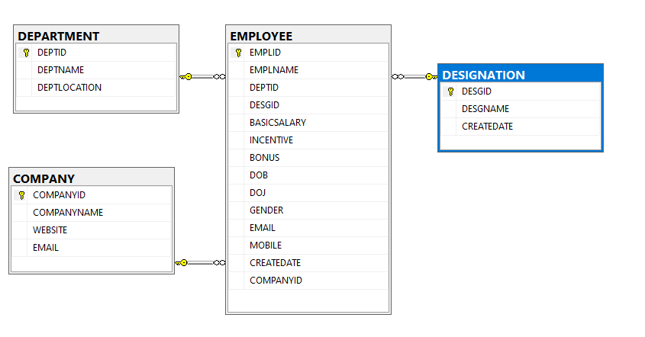
INSERT VALUES INTO ALL THE TABLES OF THE DATABASE DESIGNED
WRITE A QUERY TO JOIN ALL THE TABLES AND SHOW THE RESULTS
WRITE A QUERY TO COPY THE DATA OF ALL TABLES GENERATED USING JOINS INTO A NEW TABLE

CREATE A SALES MANAGEMENT SYSTEM DATABASE SIMILAR TO THIS.

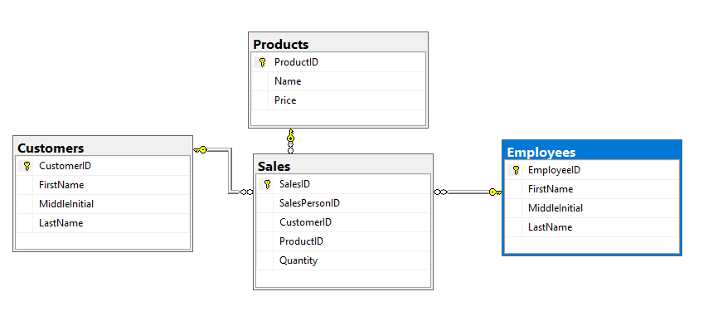
After Creating the Data Structures.
Add some Products into the tables.
Then add some Customers into the tables
Then add some employees into the tables
Then add sales data into the sales table.

